Equality Impact Assessment (EqIA)

## Skills Development Scotland has a legal duty to consider the impact of any new ‘policy’ on equality groups. A ‘policy’ in this context is taken to mean any new activity, function, policy or product, essentially anything that SDS does. Assessing impact includes considering relevant evidence, including evidence received from equality groups and the likelihood of a positive or negative impact on equality groups of introducing that new product, project or policy. The final section of this form requires us to think about how negative consequences can be mitigated against or removed, and how potential positive impacts can be encouraged. Equality impact assessment helps SDS meet its obligations under the Equality Act 2010. In addition, SDS took the decision to use the impact assessment process to make progress as a Corporate Parent in relation to care experienced young people, which is a component part of the Children and Young People (Scotland) Act 2014. The process might also be used to consider other groups that SDS has evidence of experiencing discrimination or underrepresentation.

For more detailed information about equality impact assessment, please see EHRC guidance here:

<https://www.equalityhumanrights.com/en/publication-download/assessing-impact-and-public-sector-equality-duty-guide-public-authorities>

|  |  |
| --- | --- |
| **Name of EqIA** (e.g. directorate, large project or service) | Future Workplace Practice Project – Recover phase |
| **Senior Responsible Officer (SRO):** name and job title | Carolyn Anderson, Director of HR |
| **Does your project link to any other** [**published EqIAs**](https://www.skillsdevelopmentscotland.co.uk/publications-statistics/publications/?page=1&topic%5b%5d=3-6&order=date-desc)**?**  If so please provide the name of the EqIA (e.g. WBL) | Reset & Restart [EqIA](https://skillsdevelopmentscotland.sharepoint.com/:w:/s/IShare/CorporateProgrammes/EW7Njbr6ystKmTC7jYHQsqUBri31BX8pDcBKpn5ZBlB9Ew?e=6fzrhK) |

|  |  |  |  |
| --- | --- | --- | --- |
| **Approved by:** | **Director of:** | **Date approved:** | **Review date:** |
| Signed: | HR | 14th December 2021 | N/A |

1. **Purpose of project, policy or product**

Purpose of the Future Workplace Practice project is to enable SDS colleagues to safely restart face to face engagement with customers and colleagues, in line with the Scottish Government COVID-19 Route Map response and guidelines on returning to workplaces and with the Scottish Government’s Economic Recovery Plan and in the context of the new 5 Tier Strategic Framework.

The priority focus in the initial phase (Reset & Restart project) was to enable customer facing colleagues to safely restart face to face CIAG service delivery. This project will now focus on enabling colleagues in the wider business areas to safely restart face to face contact on SDS premises and partner premises taking in consideration business requirements, personal wellbeing in the context of SG’s 5 Tier Strategic Framework, as well as SG COVID-19 Route map and associated guidance.

There are different workstreams that make up this project, however this EqIA will focus on the move to the **Recover phase** (see infographic below) – enabling our colleagues to transition to hybrid working and start returning to work from SDS recognised workplaces. This will include establishing business requirements, new workplace practices and working safely arrangements to facilitate a safe return to non-essential offices, based on office capacity and configuration in line of social distancing restrictions.

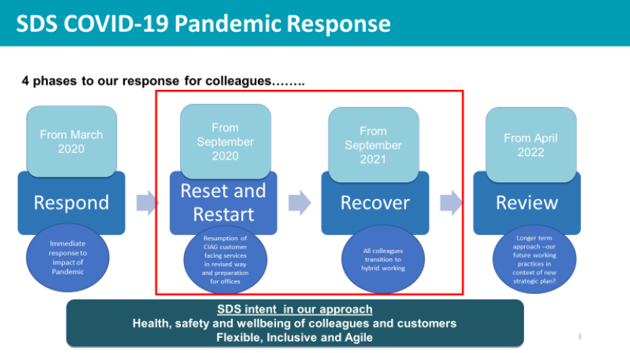

1. **Evidence and Impact**
   1. **Age**

**Context:** SDS’s workforce ranges currently from 20 to 73. At the time of doing this assessment -

* 5% of the workforce are aged 24 and under
* 24% are 55 or over

| Evidence of positive or negative impact | Source of evidence | Activity to date | Further activity required |
| --- | --- | --- | --- |
| Young Employees (24 and under)  SDS recruits new cohorts of young people annually into our Young Talent programme who have been working remotely since they joined in 2020. Young people have highlighted to SDS via our surveys that they feel they would benefit from being able to access offices as early as possible to improve their work-based learning experience. Their work-based learning would also be enhanced through experience of service delivery with customers directly | * SDS Establishment Reports * Young Talent Programme * SDS Engagement Surveys during Pandemic (PEWS) | * Planning for reset and restart we have prioritised any colleague with health and wellbeing needs to have priority access to an office (this includes young people) * Engagement with our Young Talent cohort has increased during the Pandemic and been via a variety of channels e.g. Yammer, Teams etc to support their onboarding and experience of the workplace * SDS Young Talent programme was re-designed for remote delivery during 2020 and increased opportunities for interaction * SDS Wellbeing Strategy has a variety of resources to mitigate the negative impact of remote working where possible * SDS has re-opened 40 out of 41 sites (1 under refurbishment) and people, including Young Talent, are transitioning to hybrid working and returning to work in an office. | Continue to listen to feedback from all colleagues and ensure our transition to hybrid working and access to offices and 3rd party sites supports individual health, safety and wellbeing. |
| Many of the home working environments our young people have been using whilst remote working are not a longer-term sustainable option e.g. from their bedroom | * Feedback from young people * Home Workstation Assessments | * SDS has provided equipment to home addresses to support the most optimum set up from home * SDS has prioritised colleagues for return to offices where their set up is leading to health and wellbeing concerns | No further action required |
| Older Employees  Older employees are more likely to have underlying health conditions and may anxious about returning to an office and increased risk of catching COVID-19 | * Feedback from TU colleagues * OH advice and guidance | * SDS has an HR Case Advice team who will support and advise People Managers on individual situations regarding health * SDS utilises the COVID Age Risk Assessment to support a return to work alongside a variety of wider resources e.g Occupational Health * For any employee whose health would be impacted by a return to office SDS would seek to identify and implement appropriate reasonable adjustments | No further action required |

* 1. **Disability**

**Context:** 7% of SDS employees recognised themselves as having a disability at the time of doing this assessment. It is likely this % is higher when you consider those with long term underlying health conditions that we are aware of.

| Evidence of positive or negative impact | Source of evidence | Activity to date | Further activity required |
| --- | --- | --- | --- |
| Colleagues returning to an office who have a disability may not be returning to the same office, or with the same colleagues – this could lead to anxiety and concern about returning to an office. Furthermore, there is a need to ensure there is a personal emergency evacuation plan for each colleague who may need assistance to safely evacuate the building. | SDS Transition Plan which notes closure of Adelphi, and reduced capacity  Feedback from colleagues regarding their anxiety about travelling to, and being in an office since Pandemic | * SDS has designed a ‘Return to Work’ conversation for People Managers to ensure discussions around returning to an office are personalised and offer the right support. * Any reasonable adjustments regarding equipment will where possible be mirrored in the office environment | As we move into offices opening HR Case Advice team will stay in close contact with People Managers to ensure the right advice and support are available for colleagues.  Review emergency evacuation equipment needs for Lomond and Monteith, as there are no ground floor desks or meeting rooms on either of those sites. |
| Transitioning into hybrid working (defined as moving away from 100% working from home due to the Covid-19 pandemic) could be more daunting for colleagues with disability, including colleagues suffering from mental health, anxiety and other. | Discussion on press and social media | * SDS has designed a Return to Work conversation for People Managers to ensure discussions around returning to an office are personalised and offer the right support. * Sensibilisation on possible exemptions for wearing the mask in the office, as there are “invisible” disabilities which should not be disclosed to justify the exemption. | Continue monitoring the situation through the people managers and their Monthly conversations with employees. |

* 1. **Gender reassignment** (sometimes under heading of Transgender)

The above group has no perceived impact on the activity of the project.

* 1. **Marriage and civil partnership**

**Context:** The above has no impact on the activity of the project.

* 1. **Pregnancy and maternity**

**Context:** SDS has on average 20 colleagues on maternity leave at any given time.

| Evidence of positive or negative impact | Source of evidence | Activity to date | Further activity required |
| --- | --- | --- | --- |
| For colleagues who have been on maternity leave in 2021 so far they may not be aware of SDS plans to Transition to Hybrid Working when permitted given they are not at work. | SDS establishment reports confirming current employees on maternity or due to go. | People Managers are encouraged to ensure they regularly check in with colleagues on maternity particularly in the lead up to their return  Those on maternity would undertake a Return to Work conversation with their People Manager which would help prepare for their returning | N/A |

* 1. **Race**

The above group has no perceived impact on the activity of the project.

* 1. **Religion or belief**

The above group has no perceived impact on the activity of the project.

* 1. **Sex** (or gender)

**Context:** At the time of completing this assessment 70% of the organisation was female and 30% male.

| Evidence of positive or negative impact | Source of evidence | Activity to date | Further activity required |
| --- | --- | --- | --- |
| The permanent switch to more home working following the pandemic will cause rising gender inequality in the workplace, according to experts, unless employers carefully monitor their new working policies to make sure women aren’t disadvantaged. Resumption of service delivery directly with customers on 3rd party sites will not add to or detract from impacts | The Guardian, link to [article](https://www.theguardian.com/business/2021/jun/19/switch-to-more-home-working-after-covid-will-make-gender-inequality-worse) | Continued to review data on flexible working requests and impact Pandemic has had on various business areas. This is recognising that within one of our directorates the workforce is predominantly female (CIAG). | Returning to work from an SDS sites is currently being planned, together with monitoring measurements to understand the impact of the hybrid working on women and men. |
| Based on the recent “Equality and mainstreaming report 2021-2025”, the COVID-19 pandemic impacted disproportionately on equality groups, in particular, those aged 16-24, minority ethnic communities, women and disabled people. Covid-19 had a higher impact on women as they are more likely to be primary care givers for children and elder relatives. | “Equality and mainstreaming report 2021-2025” | - SDS has designed a Return to Work conversation for People Managers to ensure discussions around returning to an office are personalised and offer the right support.  - the returning to work in the office in SDS has been a gradual process. SDS is re-opening its sites in a phased approach.  - returning to the office is completely voluntary  - we are making sure there is adequate leading time for employees to start planning to return to an office in order to allow for child care or other type of arrangements to be re-arranged. | We will continue reviewing the impact of hybrid working and Future workplace practice in a post pandemic situation through the people managers and their Monthly and return to work conversations with employees. |

* 1. **Sexual orientation**

The above group has no perceived impact on the activity of the project.

1. Assessing impact on other groups

The above group has no perceived impact on the activity of the project.

1. **Action Plan**

The SRO is responsible for all actions.

| **What is the action?** | **Which group(s) does it relate to?** | **What is the anticipated outcome?** | **What method is used to measure it?** | **Timescale** |
| --- | --- | --- | --- | --- |
| Review emergency evacuation equipment needs for Lomond and Monteith, as there are no ground floor desks or meeting rooms on either of those sites. | Disability | Lomond House emergency evacuation equipment needs has been reviewed and completed.  Monteith house arrangements will be reviewed when the office is opened | Health and safety coordinator to review and evaluate the current evacuation arrangements. | Lomond House arrangement reviewed.  Action completed  Monteith House office – in progress. Re-opening of the site to be confirmed. |